BREAKTHROUGH IN WOUND CARE IN ARMENIA AND ARTSAKH

Wound care remains a considerable medical and surgical concern in Armenia and the world, and, with the introduction of new technologies, it has evolved considerably during the past decade. At the initiative of Dr. Gevorg Yaghdjyan, an Associate Professor of Plastic Surgery, at the Yerevan State Medical University Heratsi Hospital, a wound care project was launched in April, 2016, in Yerevan. Its goal was to improve wound care in the Republic of Armenia and Artsakh by identifying, acquiring, and distributing modern equipment, an improving the education of surgeons and other health care professionals at major medical institutions.
The implementation of the program required the collaboration of several organizations. Boston, Massachusetts, area physicians, Drs Carolann Najarian and Shahe Fereshetian, accepted a donation of modern V.A.C. VERAFLO™ and V.A.C. ULTA™ units from Acelity, which help in treatment of wounds in the safest and most effective way. Ms Christine Grogan of Acelity was instrumental in making the donation of 12 machines in total sum of $717 344 happen. The Boston area Armenian-American Medical Association, funded the project. The Armenia-Artsakh Fund organized the air delivery of the devices, and the Fund for Armenian Relief ensured their receipt in Yerevan and distribution in Armenia and Artsakh.

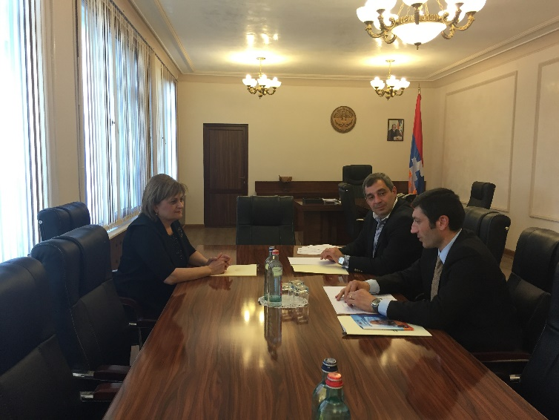
Meeting with Dr. Karine Atayan, the Minister of Health of Artsakh.

Acelity, an American company based in San Antonio, is a world leader in advanced wound care and regenerative medicine and was created by uniting the strengths of three companies, Kinetic Concepts, Inc., LifeCell Corporation, and Systagenix Wound Management, Limited (formerly Johnson & Johnson). Acelity started as an operation in a 1-bedroom apartment in San Antonio, Texas, in 1976 by an emergency room physician who saw the value of kinetic therapy in dealing with spinal cord injuries, multiple trauma, and severe pulmonary condition. From 13 original employees, Acelity now employs 5,800. Acelity is committed to restoring people’s lives around the world, and is proud to have the opportunity to donate V.A.C. VERAFLO™ and V.A.C. ULTA™ Therapies for the treatment of wound care in Armenia. Each year, Acelity donates millions of dollars and products to help heal people involved in the aftermath of global tragic disasters, including Haiti, Ecuador, San Bernardino, Paris, Brussels, and the recent horrific attack in Orlando.

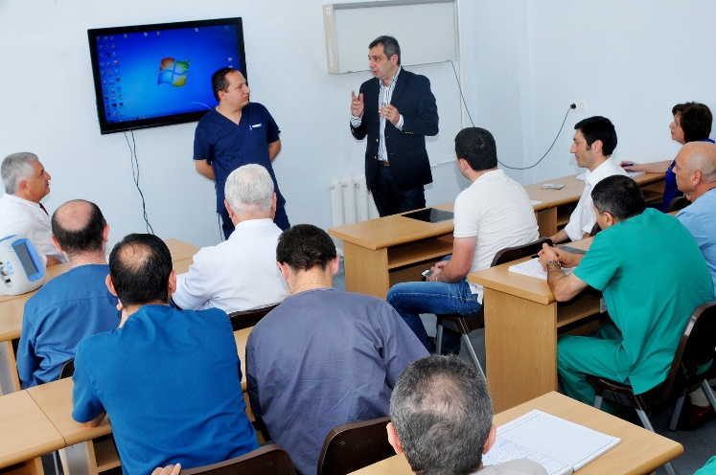
VAC equipment donation and introduction at the St. Astvatsamayr Children’s Hospital

Based on a previously established plan, the distribution of equipment started on June 22, 2016, and eight medical centers, including the St. Astvatsamayr Children's Hospital, received V.A.C. VERAFLO™ and V.A.C. ULTA™ equipment.

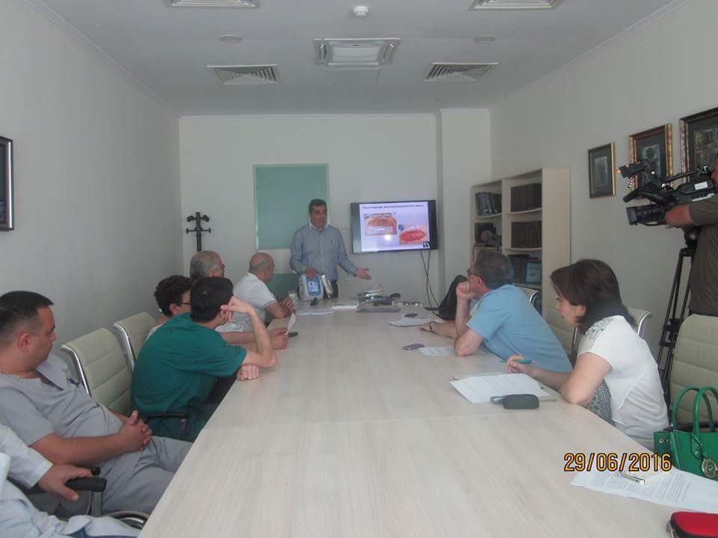
Training session at the Stepanakert Republican Hospital

In parallel with the distribution of the equipment, training of medical personnel started on June 16, 2016. Dr. Allen Gabriel, from Portland, Oregon, gave a first teleconference presentation to teams of physicians in Gumri, Stepenakert, and Yerevan.

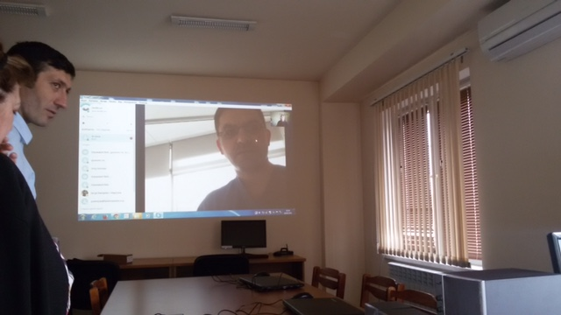
Dr. Allen Gabriel giving a teleconference presentation

